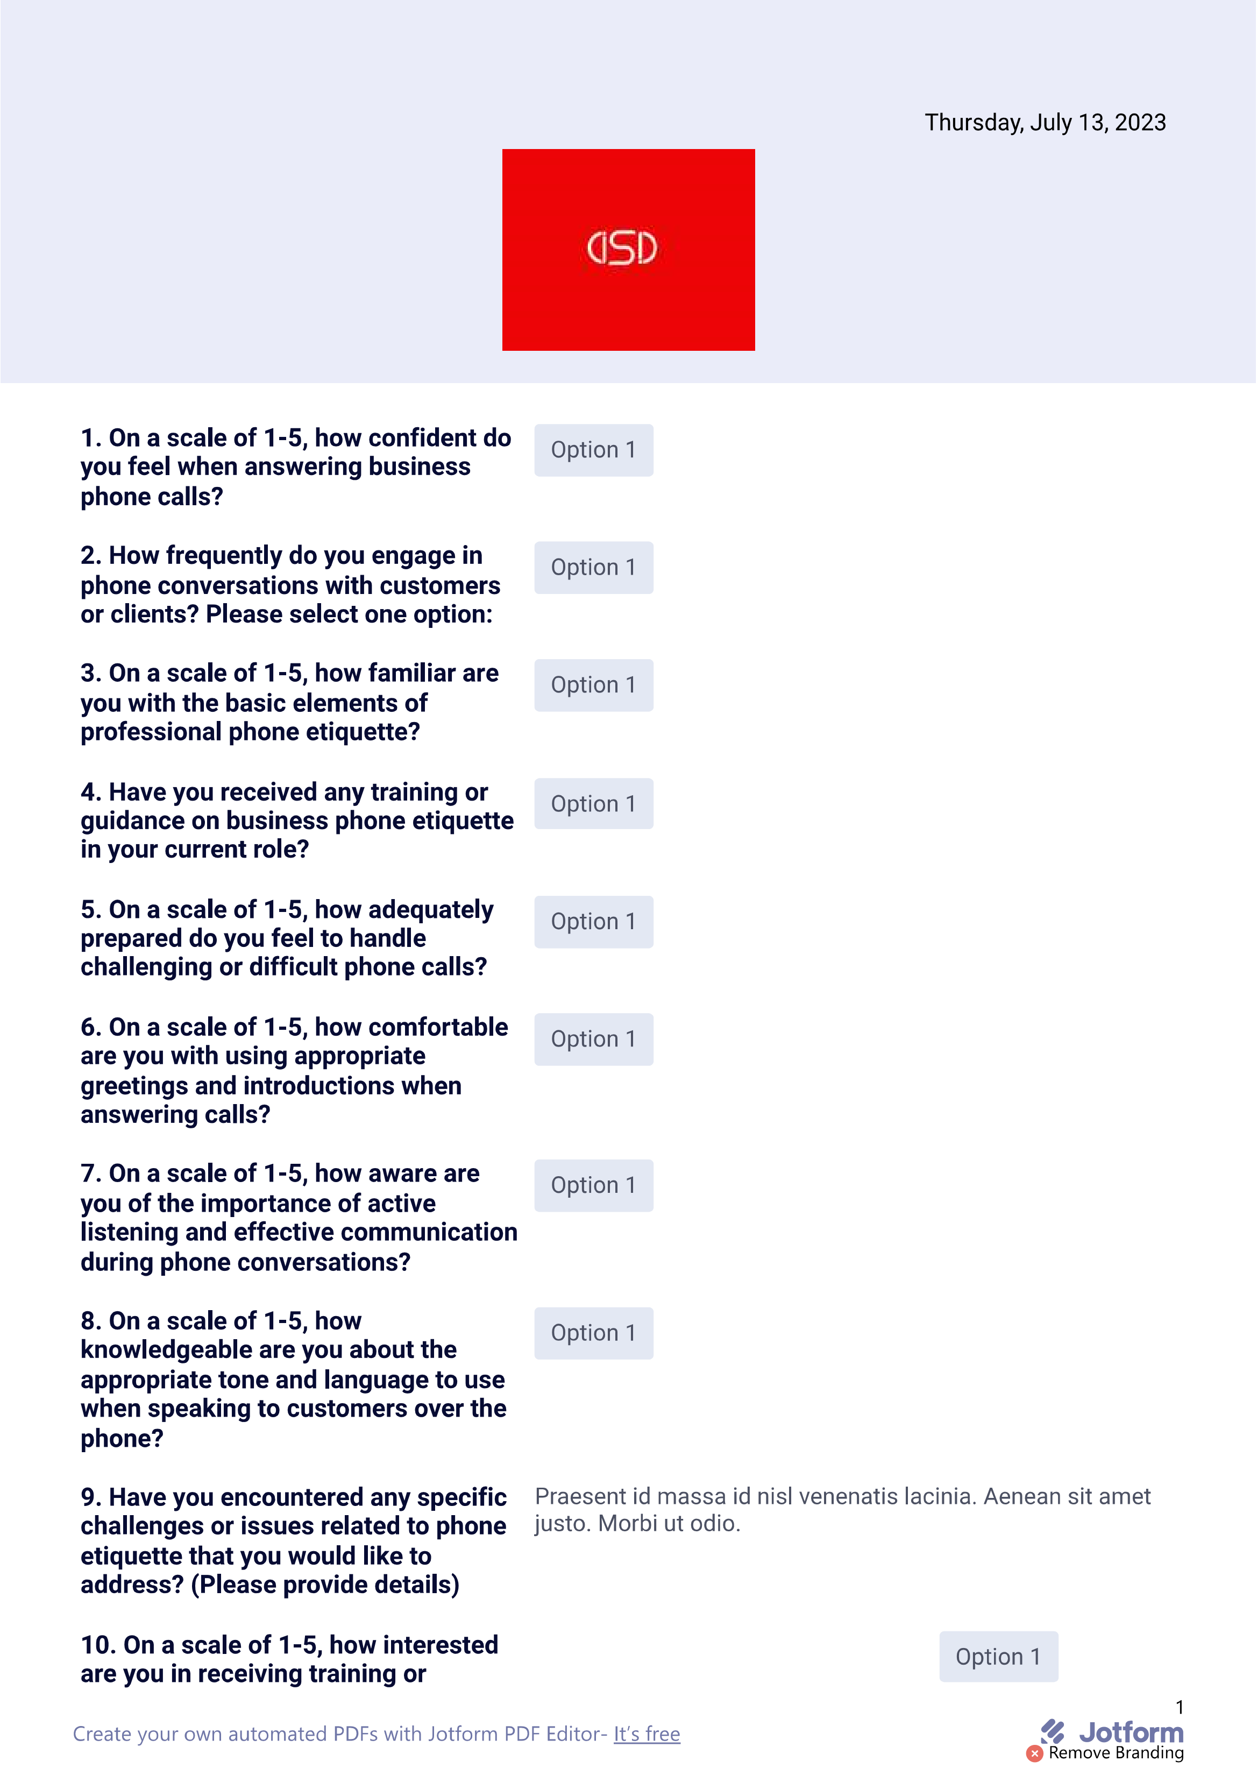

QR Code to be disseminated via all social media.